DISEASE PREDICTION SYSTEM

A Project Report Submitted in the partial fulfillment of the requirements for the award of the degree of

BACHELOR OF TECHNOLOGY
In

DEPARTMENT OF COMPUTER SCIENCE AND ENGINEERING
By
P. Pardhasaradhi | : 2420030088
M. Sai Shashank | : 2420030210
P. Venkata Sai Charan | : 2420030339

Under the Esteemed Guidance of

Dr. N. Sunanda

Associate Professor

Department of Computer Science and Engineering

AY- 2026-2027 | Group No: 14 | Section: 8

Semester: Odd | Course: Data Science (24AD3107)




K L (Deemed to be) University DEPARTMENT OF COMPUTER SCIENCE AND ENGINEERING

Declaration

The Project Report entitled “DISEASE PREDICTION SYSTEM” is a record of Bonafide work of P. Pardhasaradhi – 2420030088, M. Sai Shashank – 2420030210, P. Venkata Sai Charan – 2420030339 submitted in partial fulfillment for the award of B. Tech in Computer Science and Engineering to the K L University. The results embodied in this report have not been copied from any other departments/University/Institute.

P. Pardhasaradhi – 2420030088
M. Sai Shashank – 2420030210
P. Venkata Sai Charan – 2420030339

K L (Deemed to be) University DEPARTMENT OF COMPUTER SCIENCE AND ENGINEERING

CERTIFICATE

This is to certify that the mini project based report entitled “DISEASE PREDICTION SYSTEM” is a bonafide work done and submitted by P. Pardhasaradhi – 2420030088, M. Sai Shashank – 2420030210, P. Venkata Sai Charan – 2420030339 in partial fulfillment of the requirements for the award of the degree of BACHELOR OF TECHNOLOGY in Department of Computer Science and Engineering, K L (Deemed to be University), during the academic year 2026-2027.

Signature of the Guide

Signature of the Course Coordinator Signature of the HOD

ACKNOWLEDGEMENT
The success in this project would not have been possible but for the timely help and guidance rendered by many people. Our wish to express my sincere thanks to all those who has assisted us in one way or the other for the completion of my project.

Our greatest appreciation to my Course Coordinator [Course Coordinator Name], and my guide Dr. N. Sunanda, Associate Professor, Department of Computer Science and Engineering which cannot be expressed in words for his/her tremendous support, encouragement and guidance for this project.

We express our gratitude to P Venkateshwara Rao, Head of the Department for Computer Science and Engineering for providing us with adequate facilities, ways and means by which we are able to complete this project-based Lab.

We thank all the members of teaching and non-teaching staff members, and also who have assisted me directly or indirectly for successful completion of this project. Finally, I sincerely thank my parents, friends and classmates for their kind help and cooperation during my work.

P. Pardhasaradhi – 2420030088
M. Sai Shashank – 2420030210
P. Venkata Sai Charan – 2420030339

Abstract
The “Disease Prediction System” is a data science and machine learning-based project designed to predict the likelihood of a disease based on the symptoms provided by a user. The main objective of this system is to assist users in obtaining an early prediction of possible diseases and to provide useful information for further medical consultation. The system uses a dataset containing various symptoms and their corresponding diseases. The data is preprocessed by handling missing values, encoding relevant features, and preparing the dataset for machine learning.

Machine learning algorithms are trained on the processed dataset to identify patterns and relationships between symptoms and diseases. When a user enters their symptoms, the trained model analyzes the input and predicts the most likely disease. The system can be implemented using Python along with libraries such as Pandas, NumPy, Matplotlib, Seaborn, and Scikit-learn. Different machine learning algorithms can be evaluated to select a model that provides better prediction performance.

The proposed system demonstrates how data science and machine learning can be applied to healthcare-related problems. It can provide quick preliminary predictions and serve as an educational or decision-support tool. However, the predictions are not intended to replace professional medical diagnosis or consultation.

Keywords: Disease Prediction, Data Science, Machine Learning, Healthcare, Symptoms, Classification, Python.
Index
S. No. | Chapters | Topics | Page.no
 |  | Acknowledgement | ii
 |  | Abstract | iii
1 | Introduction | 1.1 Background of the project  1.2 Problem statement  1.3 Scope of the project  1.4 Objective(s)  1.5 Importance of the application  1.6 Target users/audience  1.7 Literature survey  1.8 Problem gap identification and novelty | 1-5
2 | System Requirements | 2.1 Hardware requirements  2.2 Software requirements  2.3 Development tools and frameworks | 6
3 | Technology Stack | 3.1 Front-end  3.2 Back-end  3.3 Database  3.4 Version control  3.5 APIs or external services | 7-8
4 | System Architecture | 4.1 High-level architecture diagram  4.2 Description of each layer  4.3 Deployment architecture | 9-10
5 | Design | 5.1 Wireframes or mockups  5.2 ER diagram / database schema  5.3 Data flow diagrams | 11-14
6 | Implementation | 6.1 Module-wise implementation  6.2 Front-end logic (UI rendering, state management)  6.3 Backend logic (training, prediction and business logic)  6.4 Database connectivity  6.5 API integration  6.6 Authentication and authorization | 15-18
7 | Features | 7.1 List of main features  7.2 How each feature works | 19
8 | Testing | 8.1 Postman testing (frontend/backend)  8.2 Integration testing  8.3 Tools used for testing  8.4 Test cases and results | 20-23
9 | Deployment | 9.1 Steps to deploy  9.2 Environment configuration  9.3 Hosting of frontend and backend | 24
10 | Challenges & Limitations | 10.1 Issues faced during development  10.2 Solutions applied  10.3 Current limitations or known bugs | 25-26
11 | Future Enhancements | 11.1 Planned features  11.2 Possible integrations or optimizations | 27
12 | Conclusion | 12.1 Summary of the project  12.2 What was achieved  12.3 Skills learned during development | 28
13 | References | - Books, tutorials, APIs, documentation sites used | 29
14 | Appendices | - Screenshots / output screens of the app  - Sample code snippets  - Installation/setup instructions  - User manual or guide  - Certifications | 30-32

CHAPTER 1
Introduction

1.1 Background of the project
Healthcare decisions often begin with a simple question: “What could be causing these symptoms?” Many common illnesses such as the common cold, flu, dengue, typhoid and pneumonia share overlapping symptoms such as fever, cough, headache and fatigue. Without access to a doctor, a patient may find it difficult to decide how serious the condition is, which specialist to consult, or how quickly to seek care.
Data Science and Machine Learning (ML) provide a systematic way of learning such symptom–disease relationships from data. A model trained on a labelled dataset can learn which combinations of symptoms are typical for each disease and can then estimate the likelihood of each disease for a new set of symptoms entered by a user.
The Disease Prediction System developed in this project is a data science and machine learning-based application that predicts the most likely disease from the symptoms selected by a user. It is built in Python using Pandas, NumPy, Matplotlib, Seaborn and Scikit-learn, and is delivered through an interactive Streamlit web interface. After prediction, the system also recommends an appropriate doctor/specialist and shows general health guidance together with emergency warning signs.
The project follows the complete data science life cycle: data collection, preprocessing, exploratory data analysis (EDA), model training, model comparison, model selection, and deployment as a user-facing application. The system is meant to be a preliminary decision-support tool and not a replacement for professional medical diagnosis.

1.2 Problem statement
Diagnosing a disease normally requires clinical examination, medical history and laboratory tests. Meanwhile, many diseases present with similar or overlapping symptoms, which makes early identification difficult, and people may delay seeking medical attention because immediate access to healthcare guidance is not available. The key problems addressed by this project are:
- Many diseases share similar symptoms, making early identification difficult.
- Users may delay medical consultation because of a lack of quick healthcare guidance.
- Traditional diagnosis depends on clinical examination, medical history and laboratory tests, which are not instantly available.
- There is a need for a data-driven system that analyses symptoms and gives a preliminary indication of possible diseases.
The proposed system uses Machine Learning algorithms to learn patterns from a disease–symptom dataset. Users enter their symptoms through a web interface, and the system predicts the most likely condition, the appropriate doctor/specialist category and general health guidance. The prediction is intended as a decision-support tool and not as a replacement for professional medical diagnosis.

1.3 Scope of the project
Within the scope of the project:
- A dataset of 1,500 records with 24 binary symptoms and 10 diseases (Common Cold, Flu, Dengue, Typhoid, Pneumonia, Migraine, Gastroenteritis, Diabetes, Hepatitis and Allergy).
- Data preprocessing (numeric conversion, median imputation of missing values, scaling for KNN) and exploratory data analysis.
- Training and comparison of four ML models: Decision Tree, Random Forest, K-Nearest Neighbors and Naive Bayes, using Accuracy, Precision, Recall and F1-score.
- Automatic selection and saving of the best model, and prediction with top-5 probability scores.
- Doctor/specialist recommendation, general care guidance and emergency warnings for each predicted disease.
- An interactive Streamlit web application with four modules: Home, Dataset & EDA, Model Comparison and Disease Prediction.
Outside the scope of the project:
- Clinical diagnosis, treatment planning or prescription of medicines or doses.
- Use of real patient records, laboratory results, imaging data or patient history.
- User accounts, a hospital/doctor database or online consultation.

1.4 Objective(s)
- Develop a Machine Learning-based system for preliminary disease prediction.
- Collect and preprocess disease–symptom data for analysis.
- Identify symptom patterns using Exploratory Data Analysis (EDA).
- Train and compare Decision Tree, Random Forest, KNN and Naive Bayes models.
- Select the best-performing model using Accuracy, Precision, Recall and F1-score.
- Automatically predict the most likely disease from user-selected symptoms.
- Recommend an appropriate doctor/specialist based on the predicted condition.
- Provide general health guidance and emergency warnings to support users in seeking appropriate medical care.
- Develop an interactive web interface using Python and Streamlit.

1.5 Importance of the application
- Early awareness: gives users a quick, preliminary indication of what their symptoms may point to, encouraging timely medical consultation.
- Right specialist: recommends the category of doctor to visit (for example Pulmonologist for Pneumonia, Endocrinologist for Diabetes), saving time.
- Data-driven and transparent: the comparison of four algorithms with standard metrics gives confidence in the choice of the final model, and the top-5 probabilities show how sure the model is.
- Safety-first design: every result carries a disclaimer and emergency warning signs, and the system never prescribes medicines.
- Educational value: demonstrates how data science and ML can be applied to a healthcare problem end to end.

1.6 Target users/audience
- General public who want a preliminary understanding of their symptoms before visiting a doctor.
- Students and faculty studying data science, machine learning and healthcare analytics.
- Healthcare awareness programmes and primary-care helpdesks that need a simple decision-support aid (after validation on real clinical data).
- Developers and researchers who want a base project that can be extended with real clinical datasets and advanced models.

1.7 Literature survey
Several researchers have studied symptom-based disease prediction using Machine Learning. A summary of the papers reviewed for this project is given in Table 1.1.
Table 1.1: Summary of literature survey
Authors / Title | Methodology | Inferences | Limitations / Future work
Fatemeh Sogandi et al. [1]  Identifying diseases symptoms and general rules using supervised and unsupervised machine learning | Supervised ML classification; unsupervised ML; association rule mining (Apriori) | Identifies relationships between symptoms and diseases; extracts useful symptom–disease rules; can support healthcare professionals and patients. | Requires validation on broader datasets; real-world clinical deployment needs further evaluation.
Rinkal Keniya et al. [2]  Disease Prediction From Various Symptoms Using Machine Learning | Multiple ML algorithms; Weighted KNN; uses symptoms, age and gender | Dataset covers more than 230 diseases; Weighted KNN achieved 93.5% accuracy; demonstrates feasibility of symptom-based prediction. | Requires larger and more diverse clinical datasets; further validation needed before clinical use.
Deepika Joshi, Renu Kant, Sachin Shakya [3]  Disease Prediction System Using Machine Learning | ML algorithms; symptom-based classification; medical datasets | ML can predict diseases from symptoms; large healthcare datasets can support better medical decision-making. | Further improvement in prediction accuracy is required; more healthcare applications can be explored.
N. Ashok et al. [4]  Symptoms Based Disease Prediction System Using Machine Learning | Decision Tree, KNN, Naive Bayes, Random Forest; Python implementation | Predicts potential diseases from user symptoms; compares multiple ML algorithms; supports quick preliminary prediction. | Dataset quality affects prediction accuracy; further development needed for real-world healthcare use.
Riya Hedaoo et al. [5]  Disease Symptoms Prediction Application | Supervised machine learning; symptom-based prediction | ML can assist in early disease prediction; automated symptom analysis can support healthcare decision-making. | Prediction depends heavily on input symptom quality; more comprehensive datasets required.
Ridham Sood, Virat Sharma [6]  Symptom Based Disease Prediction Using Machine Learning | Decision Tree, KNN, Naive Bayes, Random Forest; user symptoms as input | ML models estimate disease likelihood; demonstrates ML for healthcare decision support. | Needs broader validation with real-world patient data; model explainability can be improved.

1.8 Problem gap identification and novelty
The literature shows that symptom-to-disease prediction is feasible, but the following gaps remain:
- Existing systems mainly focus on basic symptom-to-disease prediction and support only a limited number of diseases and symptoms.
- Some approaches do not give a clear doctor/specialist recommendation after prediction.
- Limited use of multiple ML algorithms and model comparison reduces confidence in model selection.
- Many systems lack an interactive, user-friendly web interface for symptom entry.
- Real-world healthcare data contains missing values, noise and inconsistent symptom patterns.
The Disease Prediction System addresses these gaps by combining, in one platform: (i) AI-based prediction from user-reported symptoms, (ii) comparison of four ML models, (iii) an interactive symptom-entry interface, (iv) doctor recommendation, (v) general health guidance with emergency warnings, and (vi) top-5 prediction probabilities. The design is future-ready and can be extended with real clinical datasets, patient history, laboratory results and advanced ML models.

CHAPTER 2
System Requirements

2.1 Hardware requirements
The application is lightweight: the dataset is about 160 KB and the saved Random Forest model is about 21 MB. The following configuration is sufficient to train the models and run the web interface.
Table 2.1: Hardware requirements
Component | Minimum | Recommended
Processor | Dual-core, 2.0 GHz (Intel Core i3 or equivalent) | Quad-core, 2.5 GHz or higher (Intel Core i5 / Ryzen 5)
RAM | 4 GB | 8 GB or more
Storage | 500 MB free disk space (Python libraries + project) | 1 GB free disk space
Display | 1280 × 720 | 1920 × 1080 (wide layout used by the app)
Network | Required only to install the Python packages | Broadband for installation and browser access

2.2 Software requirements
Table 2.2: Software requirements
Software | Requirement
Operating system | Windows 10/11, Ubuntu/Linux or macOS
Programming language | Python 3.10 (the project was developed and compiled with CPython 3.10)
Python libraries | pandas, numpy, matplotlib, seaborn, scikit-learn, streamlit, joblib (listed in requirements.txt)
Web browser | Google Chrome, Microsoft Edge or Mozilla Firefox (latest version)
Package manager | pip

2.3 Development tools and frameworks
- Python – core programming language for data handling, ML and the web interface (any Python IDE/editor such as VS Code or PyCharm can be used).
- Scikit-learn – pipelines, preprocessing, ML models and evaluation metrics.
- Streamlit – framework for building the interactive web application purely in Python.
- Matplotlib and Seaborn – plotting of EDA charts, model-comparison charts and the confusion matrix.
- Joblib – saving the best trained model to disk (best_model.joblib).

CHAPTER 3
Technology Stack
The system is implemented completely in Python. Unlike a conventional web application, it does not need separate HTML/CSS/JavaScript, a REST server or a database server: Streamlit renders the interface directly from Python code, and the data is stored in flat files.
Table 3.1: Technology stack summary
Layer | Technology used | Purpose
Front-end | Streamlit | Interactive web pages, radio buttons, metrics, tables and charts
Back-end | Python 3.10, Pandas, NumPy, Scikit-learn, Joblib | Data processing, model training, evaluation and prediction
Visualisation | Matplotlib, Seaborn | EDA charts, heatmaps, confusion matrix, probability bar chart
Data storage | CSV file, Joblib file, Python dictionary | Dataset, trained model, disease information
Version control | Project folder (Git/GitHub recommended) | Source management
External APIs | None | The system works fully offline

3.1 Front-end
The front-end is built with Streamlit (app.py). Streamlit converts a Python script into a web app: widgets such as st.radio, st.columns, st.metric, st.dataframe and st.pyplot are used to build the four modules (Home, Dataset & EDA, Model Comparison and Disease Prediction). A sidebar radio menu is used for navigation, and status boxes (st.success, st.info, st.warning, st.error) are used to present the prediction result, the doctor recommendation, medicine caution and the emergency warning.

3.2 Back-end
The back-end logic is written in Python and is split into three files: data_generator.py (symptom list, disease patterns and dataset creation), train_model.py (preprocessing, training, comparison and model saving) and disease_info.py (doctor, description, care steps and medicine advice per disease). Key libraries are:
- Pandas and NumPy – loading the CSV, converting symptoms to numbers and handling missing values.
- Scikit-learn – Pipeline, SimpleImputer, StandardScaler, DecisionTreeClassifier, RandomForestClassifier, KNeighborsClassifier, GaussianNB, train_test_split and the metric functions.
- Joblib – serialising the best model together with its feature list and class names.

3.3 Database
No database management system is used. The dataset is stored as a CSV file (data/disease_symptoms.csv) and read with pandas.read_csv(); the trained model is stored as a Joblib file (best_model.joblib); and the doctor and guidance information is stored in a Python dictionary (DISEASE_INFO). This is sufficient for a dataset of 1,500 records. For a production version, a relational database such as MySQL or PostgreSQL can be used to store patient records and prediction history.

3.4 Version control
The source code is organised in a single project folder (Disease_Prediction_System) containing the Python files, the data folder and requirements.txt. Git and GitHub are recommended for tracking changes and for sharing the project; they also make it possible to deploy the application on Streamlit Community Cloud.

3.5 APIs or external services
The current system does not call any external API or cloud service. Prediction is performed locally by the trained model, and the doctor/guidance details come from the local DISEASE_INFO dictionary. This keeps the application simple, fast and independent of internet connectivity once the libraries are installed.

CHAPTER 4
System Architecture

4.1 High-level architecture diagram
The system follows a three-layer architecture consisting of the Streamlit presentation layer, the Python/Scikit-learn application (ML) layer and the data/storage layer (Figure 4.1). Figure 4.2 shows the end-to-end workflow, from data collection to prediction.
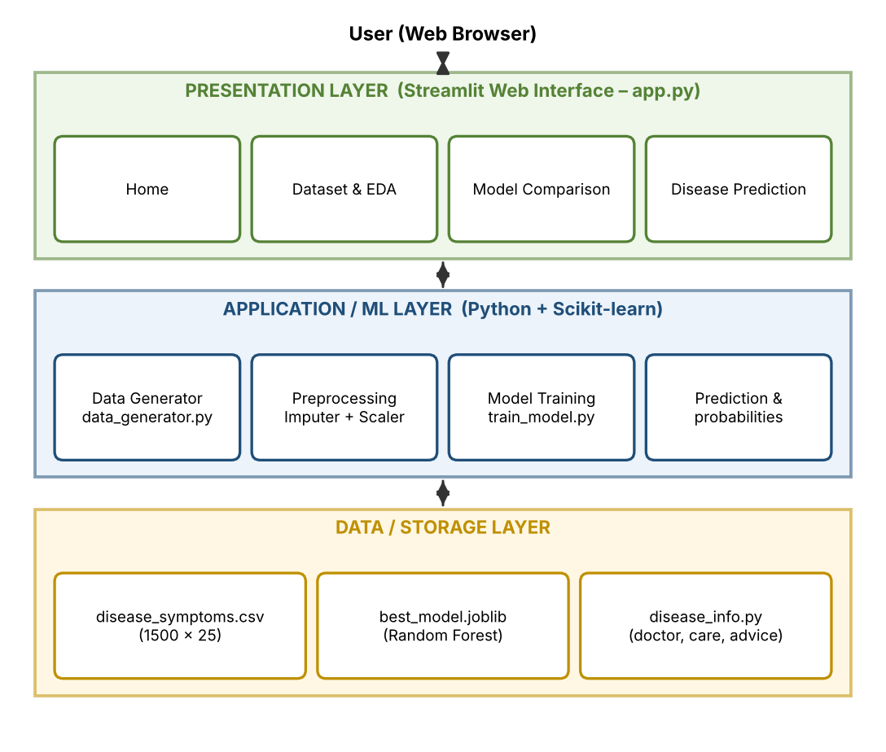
Fig 4.1: High-level architecture of the Disease Prediction System
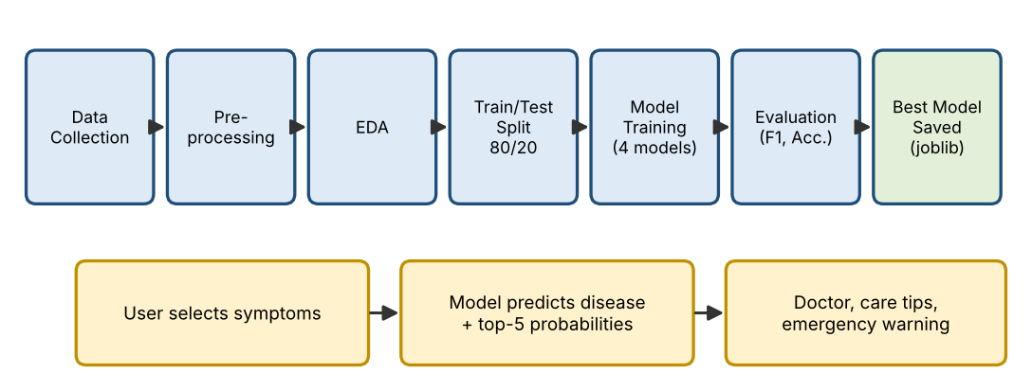
Fig 4.2: Methodology / workflow of the system

4.2 Description of each layer

Presentation layer (front-end)
Implemented in app.py using Streamlit. It displays four modules selected from the sidebar: Home (dataset size, symptom count, disease count, best model and workflow), Dataset & EDA (data preview, missing values, disease distribution, correlation heatmap, symptom frequency), Model Comparison (metrics table, bar chart, confusion matrix, classification report) and Disease Prediction (24 Yes/No symptom questions followed by the prediction result). A warning banner at the top states that the system is for educational and decision-support purposes only.

Application / ML layer (back-end)
This layer contains the business logic. data_generator.py creates the dataset; train_model.py builds four scikit-learn pipelines (imputer, optional scaler, classifier), trains them on 80% of the data, evaluates them on the remaining 20%, ranks them by weighted F1-score and saves the best one. During prediction, the selected symptoms are converted into a 24-element binary vector, and the model returns the predicted disease and class probabilities.

Data / storage layer
The data layer consists of disease_symptoms.csv (1,500 rows × 25 columns), best_model.joblib (the saved Random Forest model with features and classes) and disease_info.py (doctor, description, care steps and medicine caution for each of the 10 diseases).

4.3 Deployment architecture
The application is deployed locally as a single Streamlit process. The browser (client) connects to the Streamlit server running on the user’s machine (default address http://localhost:8501); the same Python process loads the data, trains/loads the model and renders the pages. No separate web server, database server or CI/CD pipeline is used in the current version. The same code can be hosted on a cloud platform such as Streamlit Community Cloud by pushing the project and requirements.txt to a GitHub repository; in a larger deployment, CI/CD (for example GitHub Actions) could automatically test and redeploy the application.

CHAPTER 5
Design

5.1 Wireframes or mockups
The interface is a wide-layout Streamlit page with a sidebar for navigation. Figure 5.1 shows wireframes of the Home page and of the Disease Prediction page. On the Disease Prediction page the 24 symptom questions are arranged in two columns, and the result appears automatically below them as soon as at least one symptom is set to “Yes”.
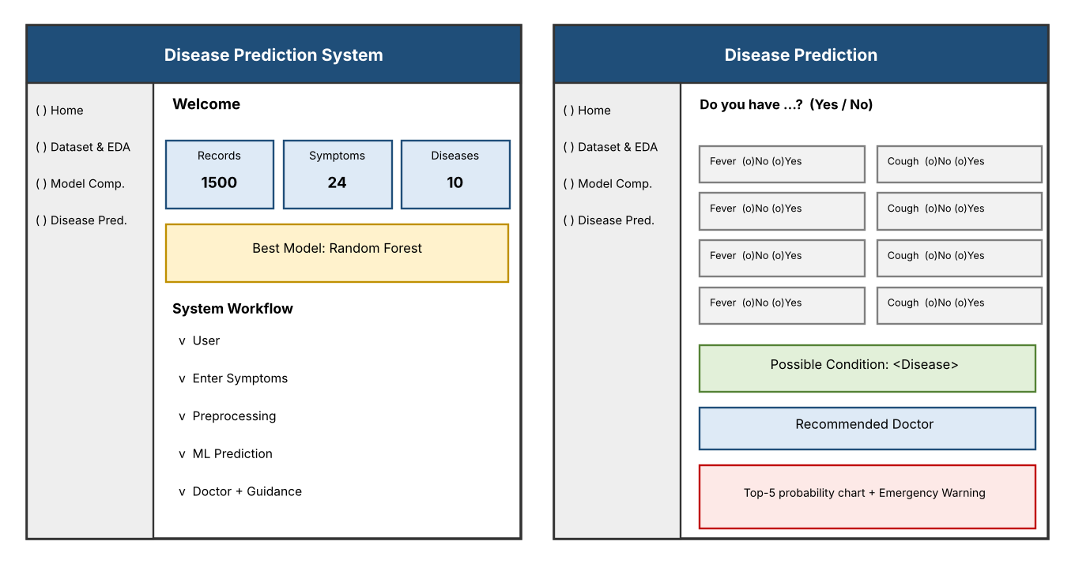
Fig 5.1: Wireframes of the Home page (left) and the Disease Prediction page (right)

5.2 ER diagram / database schema
Since the data is stored in flat files rather than a DBMS, the logical schema is shown in Figure 5.2. Every record in the symptom dataset has 24 binary symptom attributes and one disease label; each disease has exactly 150 records and one entry in the DISEASE_INFO dictionary; and the trained model stores the feature names and class names.
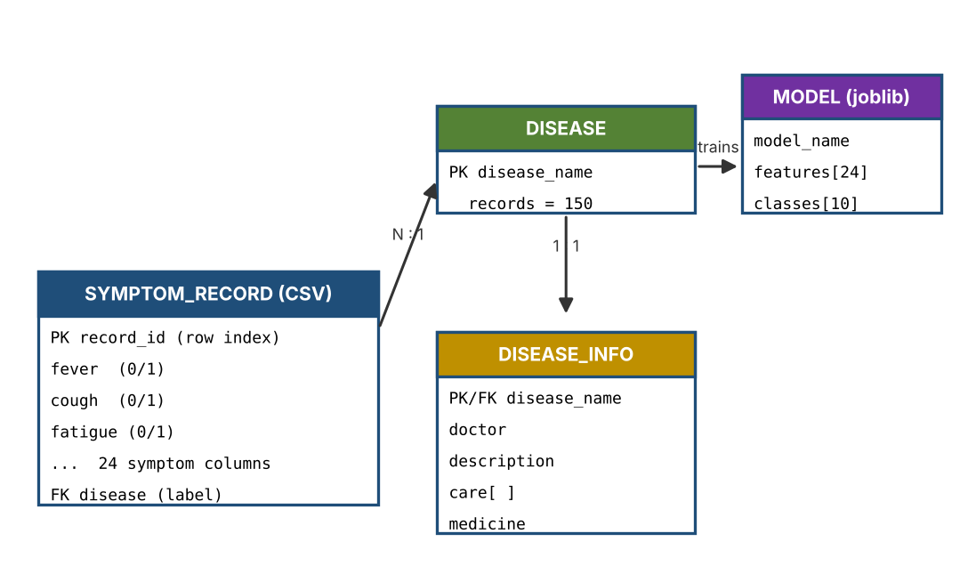
Fig 5.2: Entity-relationship / schema diagram

Dataset schema
Table 5.1: Dataset schema (1,500 rows × 25 columns)
No. | Attribute | Type | Description
1–24 | fever, cough, fatigue, headache, body_pain, sore_throat, runny_nose, shortness_of_breath, chest_pain, vomiting, nausea, diarrhea, abdominal_pain, joint_pain, skin_rash, itching, frequent_urination, excessive_thirst, blurred_vision, weight_loss, yellowish_skin, dark_urine, loss_of_appetite, dizziness | Binary (1 = present, 0 = absent); some values blank (NaN) | Symptom features (24 columns)
25 | disease | Categorical (10 classes) | Target label, 150 records per disease

Disease patterns used to build the dataset
Table 5.2: Disease patterns and recommended specialists
Disease | Core symptoms (probability 0.80) | Recommended doctor
Common Cold | cough, sore throat, runny nose, headache, fatigue | General Physician
Flu | fever, cough, fatigue, body pain, headache, sore throat | General Physician
Dengue | fever, headache, body pain, joint pain, nausea, skin rash | General Physician / Infectious Disease Specialist
Typhoid | fever, headache, abdominal pain, fatigue, loss of appetite, nausea | General Physician / Infectious Disease Specialist
Pneumonia | fever, cough, shortness of breath, chest pain, fatigue | Pulmonologist / General Physician
Migraine | headache, nausea, vomiting, dizziness, blurred vision | Neurologist / General Physician
Gastroenteritis | vomiting, nausea, diarrhea, abdominal pain, fever | General Physician / Gastroenterologist
Diabetes | frequent urination, excessive thirst, blurred vision, weight loss, fatigue | Endocrinologist / General Physician
Hepatitis | yellowish skin, dark urine, fatigue, loss of appetite, nausea, abdominal pain | Gastroenterologist / Hepatologist
Allergy | skin rash, itching, runny nose, sore throat, headache | General Physician / Allergist

5.3 Data flow diagrams
Figure 5.3 shows the level-0 data flow diagram (context diagram): the user supplies symptoms to the system and receives the predicted disease, doctor recommendation and guidance, while the system uses the dataset and the saved model/disease information. Figure 5.4 expands the system into its main processes.
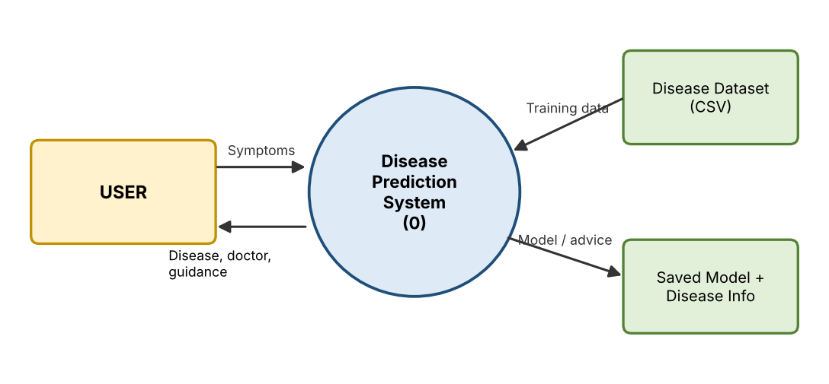
Fig 5.3: DFD Level-0
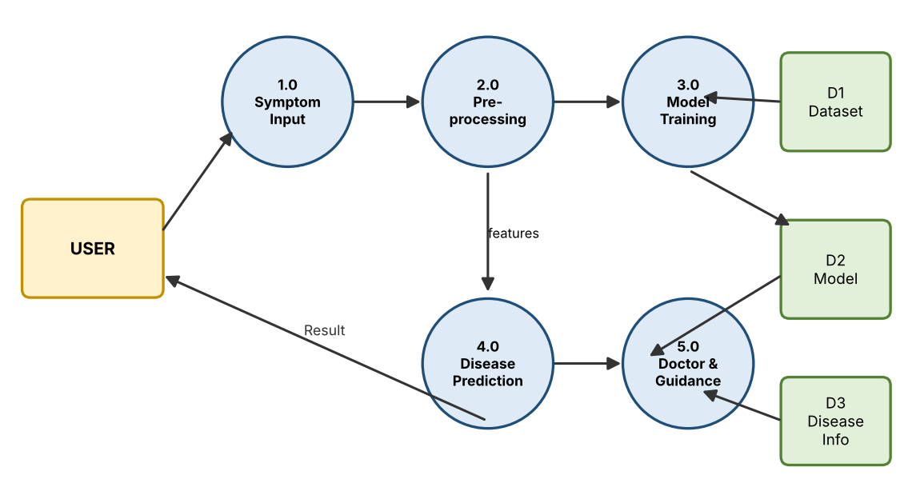
Fig 5.4: DFD Level-1

CHAPTER 6
Implementation

6.1 Module-wise implementation

Module 1: Data collection and generation (data_generator.py)
The dataset has 1,500 records and 25 columns (24 binary symptoms and one disease label) for 10 diseases with 150 records each, so the classes are balanced. It is generated in Python from a symptom pattern per disease: a core symptom of the disease appears with probability 0.80 and any other symptom with probability 0.08, using a fixed random seed of 42 for reproducibility. To mimic incomplete real-world data, 5 values per symptom column are blanked at random, giving 120 missing values in total.

Module 2: Data preprocessing
- Convert symptoms to numbers – symptoms are binary: 1 for present and 0 for absent, so the model can process them (pd.to_numeric).
- Handle missing values – median imputation (SimpleImputer) fills each missing value with the median of its feature.
- Apply StandardScaler – used in the KNN pipeline because KNN is distance-based and scaling puts features on a comparable scale.
- Train–test split – 80% training (1,200 records) and 20% testing (300 records) with stratified sampling and random_state = 42.

Module 3: Exploratory data analysis (EDA)
The EDA module (shown in the Dataset & EDA page) displays a preview of the data, the number of rows, columns and missing values, the disease distribution (balanced at 150 records per class), the symptom frequency chart and the symptom correlation heatmap. These charts are reproduced in Appendix A.1.

Module 4: Model training and evaluation (train_model.py)
Four classifiers are wrapped in scikit-learn Pipelines and trained on the same split. They are compared on the same test set using weighted Accuracy, Precision, Recall and F1-score; the model with the highest weighted F1-score is saved with Joblib.
Table 6.1: Algorithms used
Algorithm | How it works | Settings used | Pipeline steps
Decision Tree | Splits records on symptom questions (yes/no) that best separate diseases, building a tree of rules. | max_depth = 10, random_state = 42 | Imputer → Tree
Random Forest | Builds many decision trees on random samples and features; the final disease is the majority vote. | n_estimators = 250, random_state = 42 | Imputer → Forest
K-Nearest Neighbors | Finds the K most similar past records by distance and picks the most common disease among them. | n_neighbors = 7 (Euclidean distance) | Imputer → Scaler → KNN
Naive Bayes | Uses Bayes’ theorem to compute the probability of each disease given the symptoms, assuming symptoms are independent. | GaussianNB | Imputer → Naive Bayes

Evaluation metrics (weighted averages over the 10 classes): Accuracy = correct / total; Precision = TP / (TP + FP); Recall = TP / (TP + FN); F1-score = 2PR / (P + R).

Module 5: Disease information (disease_info.py)
A dictionary stores, for each disease, the recommended doctor, a short description, four general care steps and a medicine caution (for example, “Antibiotics should only be taken when prescribed by a qualified healthcare professional”). No medicine names or doses are given.

Module 6: Streamlit web application (app.py)
The web application combines all modules into four pages: Home, Dataset & EDA, Model Comparison and Disease Prediction. It is described in Sections 6.2 and 6.3 and the user view in Chapter 7.

6.2 Front-end logic (UI rendering, state management)
- Page configuration: st.set_page_config sets the title, icon and wide layout; a persistent warning banner shows the educational-use disclaimer.
- Navigation: a sidebar st.sidebar.radio selects the module; an if/elif chain renders only the chosen page.
- Model caching: the function load_model() is decorated with @st.cache_resource, so the data is loaded and the models are trained only once per server session and are reused on every interaction.
- Symptom input and state: for each of the 24 symptoms an st.radio (“No” / “Yes”) with a unique key (question_<symptom>) is shown in two columns; Streamlit preserves each widget’s state between reruns, and the list selected_symptoms is rebuilt on every rerun.
- Automatic prediction: there is no “Predict” button; as soon as at least one symptom is “Yes”, the prediction section is rendered. If none is selected, the message “Select at least one symptom.” is shown.
- Result rendering: success/info/warning/error boxes, a metric for model confidence, a dataframe of the top-5 conditions and a Matplotlib bar chart of their probabilities.

6.3 Backend logic (training, prediction and business logic)
The back-end is a set of Python functions rather than HTTP routes and controllers:
- load_data() reads data/disease_symptoms.csv (and generates it first if it does not exist).
- train_models() converts the symptom columns to numeric, performs the stratified 80/20 split, builds and fits the four pipelines, computes the four metrics, sorts by F1-score, saves the best model with its feature list and class names to best_model.joblib and returns the data needed by the UI.
- Prediction logic (in app.py) converts the selected symptoms into a 0/1 vector of length 24, calls best_model.predict() for the disease and best_model.predict_proba() for the probabilities, and keeps the five largest probabilities.
- Business logic looks up the predicted disease in DISEASE_INFO to obtain the doctor, description, care steps and medicine caution, and always appends the emergency warning and disclaimer.
The training and prediction algorithm is summarised below:
INPUT : symptom dataset D (24 symptoms, 10 diseases)
1. Convert symptoms to numeric; impute missing values (median)
2. X <- symptom columns ; y <- disease
3. Split X, y into 80% train / 20% test (stratified)
4. FOR each model M in {Decision Tree, Random Forest, KNN, Naive Bayes}:
fit M on the training set
predict on the test set
compute Accuracy, Precision, Recall, F1
5. best <- model with the highest weighted F1
6. Save best model with joblib
7. User selects symptoms -> binary vector (0/1)
8. probs <- best.predict_proba(vector)
9. OUTPUT: top-5 diseases, doctor, care tips, warning

6.4 Database connectivity
Data access is file based. The dataset is read with pandas.read_csv("data/disease_symptoms.csv"), and the trained model is written with joblib.dump() to best_model.joblib. The Streamlit app calls train_models(), which loads the CSV into a DataFrame, so no database driver or connection string is required.

6.5 API integration
No third-party or REST API is integrated. The Streamlit front-end calls the back-end functions (train_models, predict, predict_proba) directly within the same Python process, which avoids network latency. A REST API (for example, FastAPI or Flask) can be added in future so that mobile apps or other systems can use the model.

6.6 Authentication and authorization
The current version is a single-user local application, so no login or role-based access is implemented. Instead, responsible-use safeguards are built into every result: a disclaimer that the prediction cannot confirm a diagnosis, emergency warning signs (severe breathing difficulty, severe chest pain, fainting or confusion, severe dehydration, rapid worsening), and a caution that medicines must be chosen by a healthcare professional. User authentication and storage of personal health data would be required before any public deployment and must follow data-protection rules.

CHAPTER 7
Features

7.1 List of main features
- Machine Learning-based disease prediction from 24 symptoms for 10 diseases.
- Comparison of four ML models (Decision Tree, Random Forest, KNN, Naive Bayes) with automatic best-model selection.
- Interactive Yes/No symptom questionnaire with automatic prediction.
- Top-5 probable conditions with probability scores and a model-confidence value.
- Doctor/specialist recommendation for the predicted condition.
- General health guidance, medicine caution and emergency warning signs.
- Dataset & EDA module with disease distribution, symptom frequency and correlation heatmap.
- Model Comparison module with metrics table, performance chart, confusion matrix and classification report.

7.2 How each feature works
Table 7.1: Features and their working
Feature | User perspective | Technical description
Home dashboard | Sees dataset records (1,500), symptoms (24), diseases (10), the best model and the workflow. | st.metric cards computed from the DataFrame and the model-comparison result.
Dataset & EDA | Browses the first 20 rows, row/column/missing counts and three charts. | DataFrame preview; Matplotlib bar charts; Seaborn correlation heatmap of the symptom columns.
Model comparison | Compares the four models in a table and chart, and sees the confusion matrix and class-wise report. | Metrics computed with sklearn.metrics on the 300-record test set; confusion_matrix and classification_report for the best model.
Symptom questionnaire | Answers “Do you have <symptom>?” Yes/No for 24 symptoms. | 24 st.radio widgets in two columns; selected symptoms are collected in a list.
Disease prediction | Immediately sees the “Possible Condition”. | Binary vector → best_model.predict().
Confidence and top-5 | Sees how sure the model is and the other likely conditions in a table and bar chart. | best_model.predict_proba(); top-5 probabilities in percentage form; first value is shown as model confidence.
Doctor recommendation | Sees which specialist to consult. | Lookup of the predicted disease in DISEASE_INFO["doctor"].
Health guidance and safety | Reads description, care steps, medicine caution, emergency warning and disclaimer. | Lookup of description, care and medicine in DISEASE_INFO; fixed warning and disclaimer text.

CHAPTER 8
Testing

8.1 Postman testing (frontend/backend)
Postman is used to test REST API endpoints. This project does not expose any REST endpoints, because the Streamlit front-end and the Python back-end run in one process. Therefore, Postman testing is not applicable to the current version; the back-end functions were tested directly in Python and the front-end was tested through the browser (functional UI testing, Section 8.4). If a FastAPI/Flask API is added in future, its prediction endpoint can be tested in Postman by posting a JSON list of symptoms.

8.2 Integration testing
Integration testing verified that the modules work together from end to end: dataset generation/loading → preprocessing → training of four pipelines → evaluation and best-model selection → saving with Joblib → Streamlit page rendering → symptom vector creation → prediction and probabilities → doctor and guidance lookup from DISEASE_INFO. The complete pipeline was executed from train_model.py and the results (1,500 rows, 25 columns; 1,200 training and 300 testing samples; best model: Random Forest) agreed with the values displayed in the Home and Model Comparison pages.

8.3 Tools used for testing
- Python and scikit-learn metrics (accuracy_score, precision_score, recall_score, f1_score, confusion_matrix, classification_report).
- Stratified train–test split (random_state = 42) for unbiased evaluation on unseen data.
- Pandas for checking data shape, missing values and class balance.
- Streamlit in a web browser for manual functional testing of the user interface.

8.4 Test cases and results

A. Model performance (300 test records)
Table 8.1: Model comparison results (weighted averages)
Model | Accuracy | Precision | Recall | F1-score
Random Forest | 92.33% | 92.41% | 92.33% | 92.36%
KNN | 91.67% | 91.74% | 91.67% | 91.61%
Naive Bayes | 90.00% | 90.21% | 90.00% | 89.95%
Decision Tree | 76.67% | 76.14% | 76.67% | 76.23%

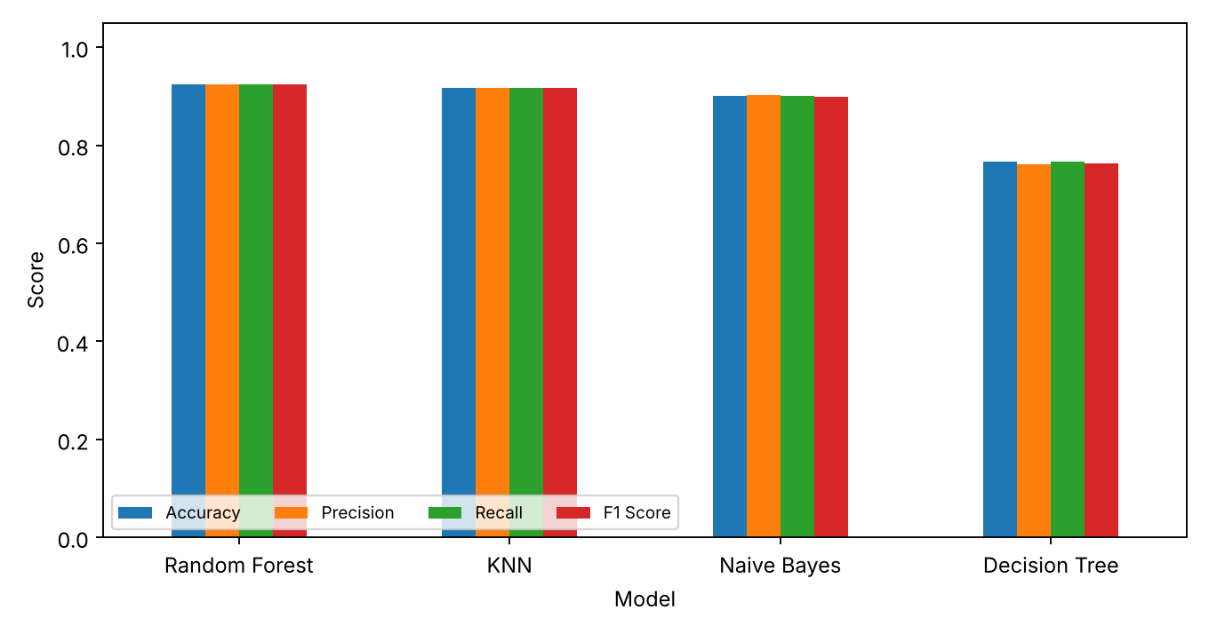
Fig 8.1: Performance comparison of the four models
Random Forest gives the best F1-score (92.36%) and is saved as the final model. KNN (91.67% accuracy) and Naive Bayes (90.00%) also perform well. The Decision Tree scores lowest (76.67%), because a single depth-limited tree is less robust than an ensemble of 250 trees.

B. Class-wise performance of the Random Forest model
Table 8.2: Classification report (test set)
Disease | Precision | Recall | F1-score | Support
Allergy | 0.93 | 0.90 | 0.92 | 30
Common Cold | 0.84 | 0.90 | 0.87 | 30
Dengue | 0.93 | 0.93 | 0.93 | 30
Diabetes | 1.00 | 1.00 | 1.00 | 30
Flu | 0.87 | 0.87 | 0.87 | 30
Gastroenteritis | 0.90 | 0.90 | 0.90 | 30
Hepatitis | 0.93 | 0.93 | 0.93 | 30
Migraine | 0.97 | 0.97 | 0.97 | 30
Pneumonia | 1.00 | 0.97 | 0.98 | 30
Typhoid | 0.87 | 0.87 | 0.87 | 30

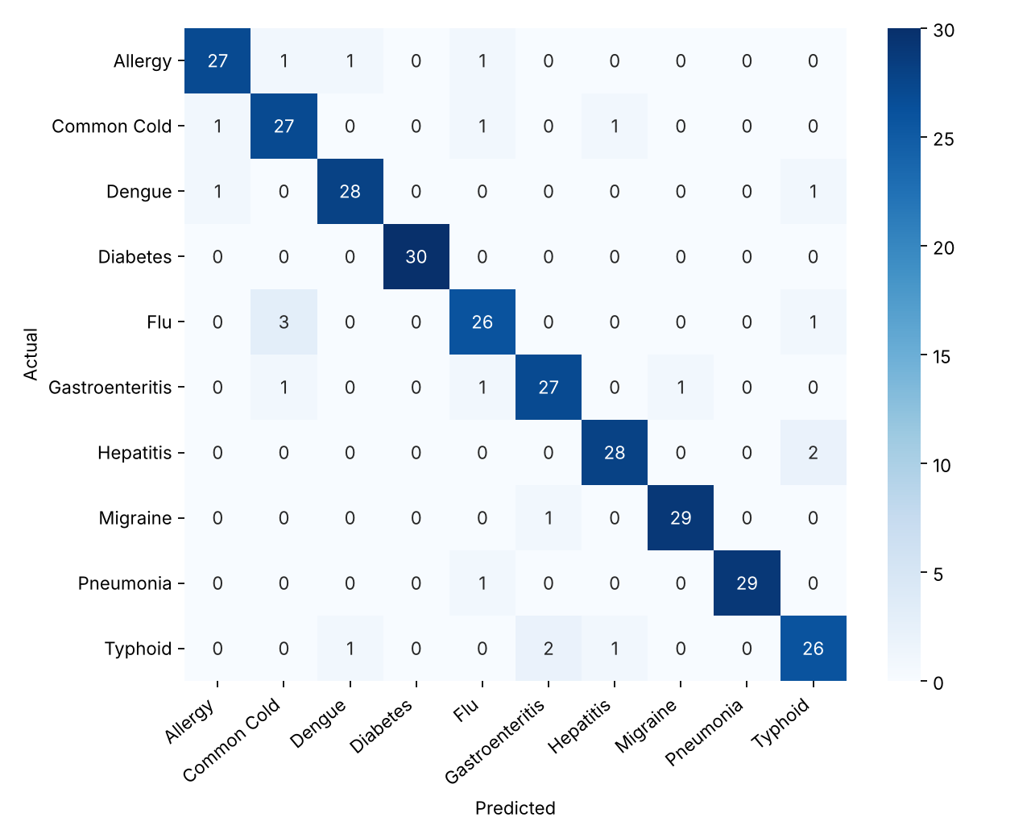
Fig 8.2: Confusion matrix of the Random Forest model
Diabetes is predicted perfectly (F1 = 1.00) and Pneumonia and Migraine almost perfectly, because their symptom sets are distinctive. Common Cold, Flu and Typhoid have the lowest F1-scores (0.87), as they share symptoms such as fever, fatigue and headache with other diseases.

C. Functional test cases (symptom input → prediction)
Table 8.3: Functional test cases executed on the trained Random Forest model
ID | Symptoms entered | Expected | Predicted | Confidence | Result
TC1 | fever, cough, shortness of breath, chest pain, fatigue | Pneumonia | Pneumonia | 100.0% | Pass
TC2 | frequent urination, excessive thirst, blurred vision, weight loss | Diabetes | Diabetes | 99.6% | Pass
TC3 | yellowish skin, dark urine, loss of appetite, nausea | Hepatitis | Hepatitis | 99.2% | Pass
TC4 | headache, nausea, vomiting, dizziness, blurred vision | Migraine | Migraine | 100.0% | Pass
TC5 | skin rash, itching, runny nose | Allergy | Allergy | 97.6% | Pass
TC6 | vomiting, diarrhea, abdominal pain, nausea | Gastroenteritis | Gastroenteritis | 100.0% | Pass
TC7 | fever, headache, body pain, joint pain, skin rash | Dengue | Dengue | 97.2% | Pass
TC8 | cough, sore throat, runny nose | Common Cold | Common Cold | 59.0% | Pass

All eight scenarios gave the expected disease. TC8 (Common Cold) has the lowest confidence (59.0%) because its symptoms (cough, sore throat, runny nose) are shared with Flu and Allergy, which is also visible in the top-5 probability table.

D. User-interface test cases
Table 8.4: UI test cases
ID | Test scenario | Expected behaviour | Result
UI1 | Open the app and select each module in the sidebar | Home, Dataset & EDA, Model Comparison and Disease Prediction pages load without error | Pass
UI2 | Open Disease Prediction with all symptoms set to “No” | Message “Select at least one symptom.” is displayed; no prediction is shown | Pass
UI3 | Set one or more symptoms to “Yes” | Prediction appears automatically with doctor, guidance, top-5 table and chart | Pass
UI4 | Change symptoms after a prediction | Result updates immediately to the new input | Pass
UI5 | Check every result page | Emergency warning and disclaimer are always displayed | Pass

Note: the dataset is generated from symptom patterns, so real clinical data may give different results; the reported metrics demonstrate the working of the pipeline and should not be read as clinical accuracy.

CHAPTER 9
Deployment

9.1 Steps to deploy
- Install Python 3.10 (or a compatible version) and verify it with python --version.
- Copy the project folder Disease_Prediction_System to the target computer.
- Open a terminal inside the project folder.
- (Optional) create and activate a virtual environment: python -m venv venv.
- Install the dependencies: pip install -r requirements.txt.
- Start the application: streamlit run app.py.
- Open the address shown in the terminal (default http://localhost:8501) in a web browser.

9.2 Environment configuration
- requirements.txt lists pandas, numpy, matplotlib, seaborn, scikit-learn, streamlit and joblib.
- Dataset: data/disease_symptoms.csv is used if present; if it is missing, load_data() creates it automatically with data_generator.py.
- Model: on first start the models are trained and the best one is saved as best_model.joblib; the result is cached for the session by st.cache_resource.
- Working directory: the app must be started from the project folder because the data and model paths are relative.
- Port: Streamlit uses port 8501 by default and can be changed with the --server.port option.

9.3 Hosting of frontend and backend
Front-end and back-end are hosted together in one Streamlit process, so there is nothing to host separately. For local or classroom demonstration, running streamlit run app.py is sufficient. For public access, the project can be pushed to a GitHub repository and deployed on Streamlit Community Cloud (or any VM/Docker host), which installs the packages from requirements.txt and serves the app over HTTPS. The 21 MB model file is small enough to be stored in the repository.

CHAPTER 10
Challenges & Limitations

10.1 Issues faced during development
- Many diseases share common symptoms (fever, fatigue, headache, nausea), which lowers the F1-score of Common Cold, Flu and Typhoid to 0.87.
- A labelled real clinical dataset with symptoms is not freely available for direct academic use, so the data had to be generated from symptom patterns.
- Real-world data contains missing, noisy and inconsistent values; the dataset was therefore generated with 120 missing values to reflect this.
- KNN is distance-based and sensitive to feature scale.
- A single Decision Tree performed poorly (76.67% accuracy) compared with the other models.
- Presenting a prediction in a medically responsible way, without causing panic or self-medication.

10.2 Solutions applied
Table 10.1: Issues and solutions
Issue | Solution applied
Overlapping symptoms | Probabilistic output: top-5 conditions with probability scores are shown instead of one label, and the best model is chosen by weighted F1-score.
No real dataset | Reproducible synthetic dataset (seed 42) with 150 balanced records per disease, core-symptom probability 0.80 and noise probability 0.08.
Missing values | Median imputation inside each scikit-learn Pipeline (fitted on training data only, which avoids data leakage).
Feature scale for KNN | StandardScaler included in the KNN pipeline.
Weak Decision Tree | Depth limited to 10 and compared with the ensemble; Random Forest (250 trees) selected as the final model.
Medical safety | Doctor recommendation, care guidance, medicine caution (no doses), emergency warning and disclaimer shown with every result.
Repeated training on every click | Training wrapped in @st.cache_resource so it runs once per session.

10.3 Current limitations or known bugs
- The dataset is synthetic. Because it is generated from the same patterns the model learns, accuracy figures are optimistic and real clinical data may give different results.
- Only 24 symptoms and 10 diseases are covered; severity, duration, age, gender, medical history and laboratory results are not considered.
- Symptoms are treated as independent Yes/No inputs, so a prediction with few symptoms (for example only “cough”) can be uncertain.
- The app retrains the models when a new session starts (train_models() is called inside load_model()), instead of loading the already saved best_model.joblib, which causes a short start-up delay.
- No user authentication, prediction history or multilingual support.
- The system has not been clinically validated and must not be used for real diagnosis.

CHAPTER 11
Future Enhancements

11.1 Planned features
- Train on real clinical datasets and add more diseases and symptoms.
- Include patient history, age, gender, symptom severity/duration and laboratory results as inputs.
- Add advanced ML models (for example Gradient Boosting, XGBoost or neural networks) and hyper-parameter tuning with cross-validation.
- Add model explainability (for example feature importance or SHAP) so users can see which symptoms influenced the result.
- Add a query box/chatbot, multilingual interface and voice input.
- Add user login with prediction history and downloadable PDF reports.
- Add the review of newly emerging diseases and seasonal outbreak alerts.

11.2 Possible integrations or optimizations
- Load the saved best_model.joblib at start-up instead of retraining, to speed up the application.
- Expose the model through a REST API (FastAPI/Flask) so that mobile and hospital applications can use it.
- Integrate a doctor/hospital finder using maps and online appointment booking.
- Store data in a database (MySQL/PostgreSQL) and deploy with Docker and a CI/CD pipeline.
- Add SMS/e-mail notifications of the prediction summary.

CHAPTER 12
Conclusion

12.1 Summary of the project
The Disease Prediction System is a data science and machine learning application that predicts the most likely disease from the symptoms entered by a user and provides the recommended specialist, general health guidance and emergency warnings. The project covered data preparation, EDA, comparison of four ML models, best-model selection and a four-module Streamlit interface.

12.2 What was achieved
- A balanced dataset of 1,500 records (24 symptoms, 10 diseases) was prepared and analysed.
- Four models were trained on a 1,200-record training set and compared on a 300-record test set; Random Forest performed best with 92.33% accuracy and 92.36% F1-score, followed by KNN (91.67%), Naive Bayes (90.00%) and Decision Tree (76.67%).
- The best model is used by the web app to show the predicted disease, confidence and top-5 probabilities, together with the doctor recommendation, care guidance and safety warnings.
- All eight functional test scenarios and five UI test cases passed.
The project shows how data science and machine learning can provide quick preliminary predictions for healthcare-related problems as an educational or decision-support tool; it is not intended to replace professional medical diagnosis.

12.3 Skills learned during development
- Data handling and cleaning with Pandas and NumPy, including imputation of missing values.
- Exploratory data analysis and visualisation with Matplotlib and Seaborn.
- Building ML pipelines, comparing classifiers and saving models (Scikit-learn, Joblib), and choosing evaluation metrics.
- Developing an interactive web application in Streamlit.
- Responsible AI practices for healthcare (disclaimers, safety warnings, awareness of data limitations), teamwork and documentation.

CHAPTER 13
References
[1] Fatemeh Sogandi et al., “Identifying diseases symptoms and general rules using supervised and unsupervised machine learning.”
[2] Rinkal Keniya et al., “Disease Prediction From Various Symptoms Using Machine Learning.”
[3] Deepika Joshi, Renu Kant and Sachin Shakya, “Disease Prediction System Using Machine Learning.”
[4] N. Ashok et al., “Symptoms Based Disease Prediction System Using Machine Learning.”
[5] Riya Hedaoo et al., “Disease Symptoms Prediction Application.”
[6] Ridham Sood and Virat Sharma, “Symptom Based Disease Prediction Using Machine Learning.”
[7] Scikit-learn documentation – https://scikit-learn.org/stable/
[8] Pandas documentation – https://pandas.pydata.org/docs/
[9] NumPy documentation – https://numpy.org/doc/
[10] Matplotlib documentation – https://matplotlib.org/stable/
[11] Seaborn documentation – https://seaborn.pydata.org/
[12] Streamlit documentation – https://docs.streamlit.io/
[13] Joblib documentation – https://joblib.readthedocs.io/

CHAPTER 14
Appendices

A.1 Screenshots of the app
The figures below are the output screens of the Dataset & EDA and Model Comparison modules of the Streamlit application, generated from the project data and code.
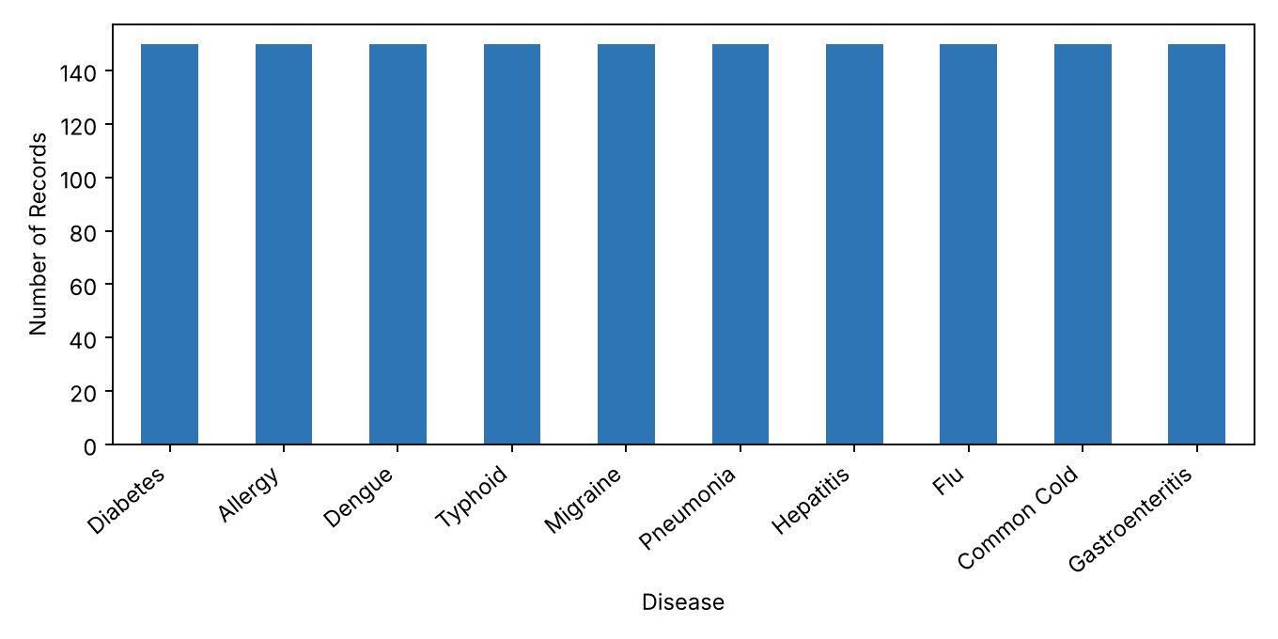
Fig A.1: Disease distribution (Dataset & EDA page)
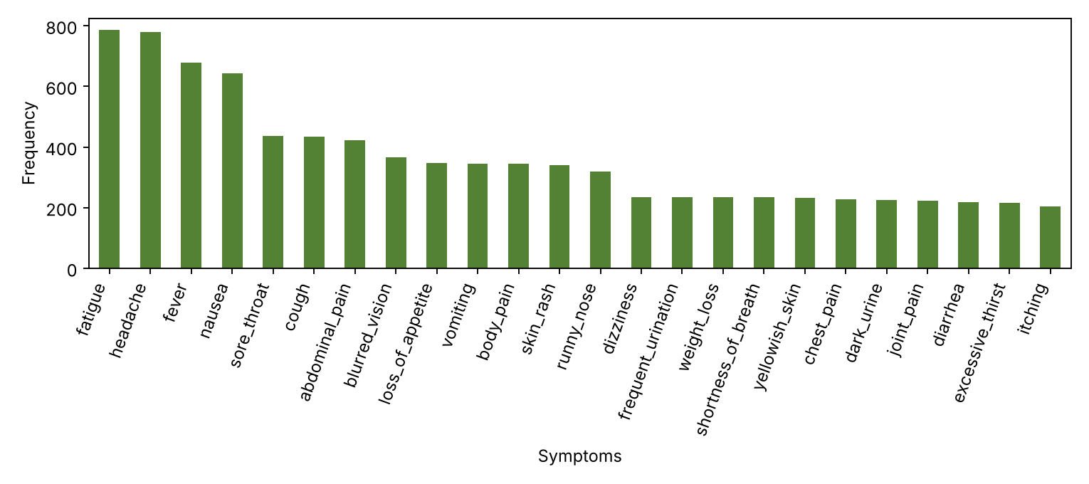
Fig A.2: Symptom frequency (Dataset & EDA page)
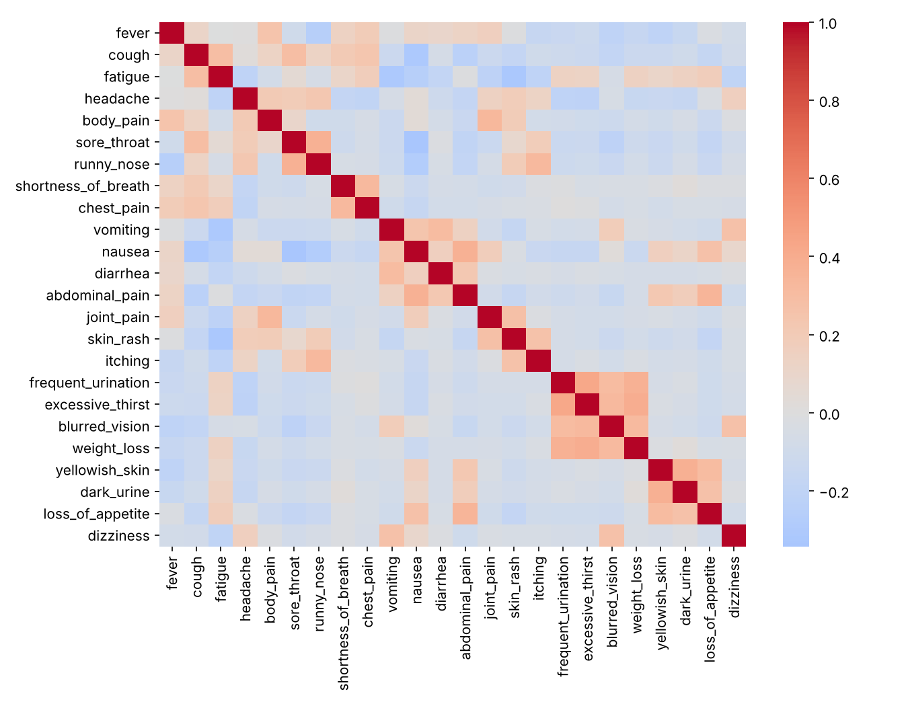
Fig A.3: Symptom correlation heatmap (Dataset & EDA page)
[Paste browser screenshots of the Home and Disease Prediction pages here, as Fig A.4 and Fig A.5]

A.2 Sample code snippets

Dataset generation (data_generator.py)
for disease, symptoms in DISEASE_PATTERNS.items():
symptoms = set(symptoms)
for i in range(rows_per_class): # 150 rows per disease
row = {}
for symptom in SYMPTOMS:
probability = 0.80 if symptom in symptoms else 0.08
row[symptom] = np.random.binomial(1, probability)
row["disease"] = disease
rows.append(row)

Model pipeline and selection (train_model.py)
"Random Forest": Pipeline([
("imputer", SimpleImputer(strategy="median")),
("model", RandomForestClassifier(n_estimators=250, random_state=42, n_jobs=-1))
]),
"KNN": Pipeline([
("imputer", SimpleImputer(strategy="median")),
("scaler", StandardScaler()),
("model", KNeighborsClassifier(n_neighbors=7))
]),
...
results_df = results_df.sort_values(by="F1 Score", ascending=False)
best_model_name = results_df.iloc[0]["Model"]
joblib.dump(model_data, MODEL_PATH)

Prediction (app.py)
input_data = [1 if s in selected_symptoms else 0 for s in features]
input_df = pd.DataFrame([input_data], columns=features)
predicted_disease = best_model.predict(input_df)[0]
info = DISEASE_INFO.get(predicted_disease, {})
probabilities = best_model.predict_proba(input_df)[0]

A.3 Installation/setup instructions
# 1. Go to the project folder
cd Disease_Prediction_System

# 2. (Optional) create a virtual environment
python -m venv venv
venv\Scripts\activate # Windows
source venv/bin/activate # Linux / macOS

# 3. Install dependencies
pip install -r requirements.txt

# 4. (Optional) regenerate the dataset and train the models
python data_generator.py
python train_model.py

# 5. Run the web application
streamlit run app.py

A.4 User manual / guide
- Run the application and open it in the browser. Read the warning that the system is for educational and decision-support purposes only.
- Use the sidebar to open Home for an overview of the dataset, the best model and the workflow.
- Open Dataset & EDA to see the data preview and the distribution, correlation and symptom frequency charts.
- Open Model Comparison to compare the four models and see the confusion matrix and classification report.
- Open Disease Prediction. For each symptom question choose “Yes” if you have the symptom, otherwise leave “No”.
- The result appears automatically: possible condition, recommended doctor, description, selected symptoms, care guidance, medicine caution, model confidence, top-5 probable conditions and an emergency warning.
- Consult a qualified doctor for diagnosis and treatment; seek urgent care if any emergency warning sign applies.

A.5 Certifications
[Attach course/workshop certificates of the team members here, if any]

